[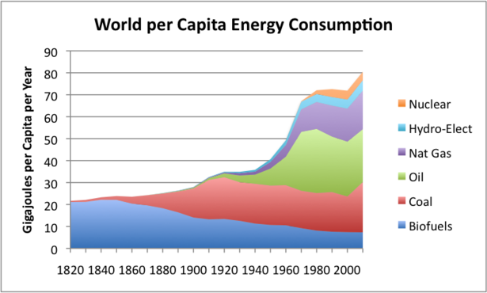](http://www.theatlantic.com/business/archive/2012/03/chart-of-the-day-a-short-history-of-200-years-of-global-energy-use/254909/)